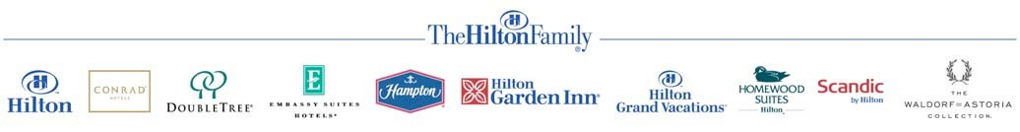

Credit Card Payment Authorization Form

Do not send completed form by email.

FAX COMPLETED FORM TO: 793 3273

ATTN: Sheldon James

Date: 03/20/2016

HOTEL USE ONLY: -
Guest / Group Name: Alex Yu Check-In / Event Date: 03/20/2016
Name of Person/Group Making Reservation: Natasha Gardner Phone: +1 839 638 732
Authorized Amount: $4,000 Approval Code:

CARDHOLDER - Please complete the following section and sign/date below.
Cardholder Name as it Appears on Credit Card: Natasha Gardner Cardholder Billing Address: 270 3rd Street Los Altos 94022
Shipping address: Same as billing address
Daytime /Business Telephone: +1 839 638 732 Evening Telephone: +1 839 638 732 Credit Card Number: 6011 1252 2370 9063 Expiration Date: Jun 2017
Credit Card Type:
☐ Visa ☐ MasterCard ☐ American Express ☐ Discover ☐ JCB ☐ Diners Club
Credit Card Issuing Bank: Citi Bank Security Number (from back of your credit card): 748

I agree to cover the following categories of charges: (Please check)
☐ All Charges ☐ Room & Tax ☐ Food & Beverage ☐ Retail ☐ Recreation

I agree to cover the above categories of charges up to a Maximum Amount of $

Note: Charges for room and tax, group deposits or direct bill account payments will be charged to your credit card immediately. Any incidental charges circled above will be charged at the time of check-out.

Amount to be immediately charged to credit card for room and taxes or deposit: $

Final Balance Billed to Credit Card (hotel use only): $

